2023 100-200 meter Nationals
Mid Carolina Gun Club
September 16TH & 17TH, 2023 Orangeburg, SC
Pre-Registration REQUIRED by 8-15-2023
Name: ___________________________
Camping- I have 15 spots with full hookup and service as well as 4 other without sewer. RESERVATION REQUIRED! Call me on my cell phone for confirmation 843-957-6546.
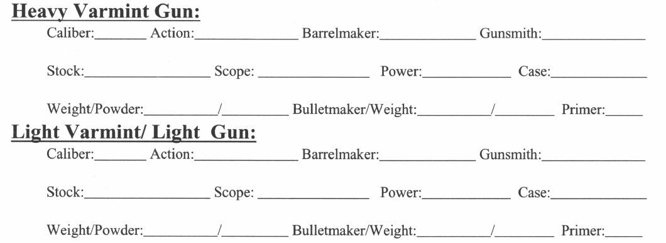
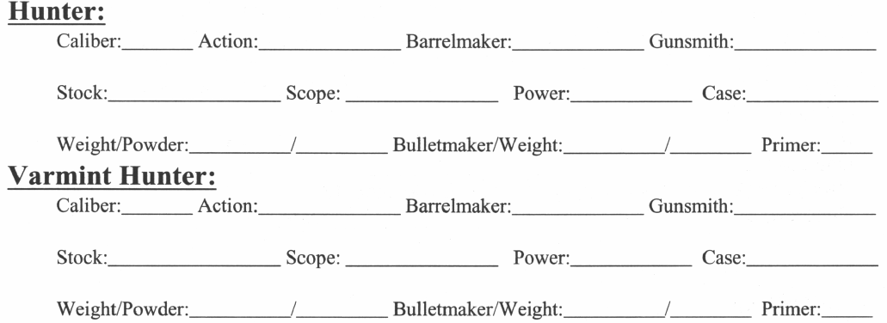
Please mail to:
Jim Cline
1172 lulu loop
Murrells Inlet, SC 29576
843-957-6546 (cell)

